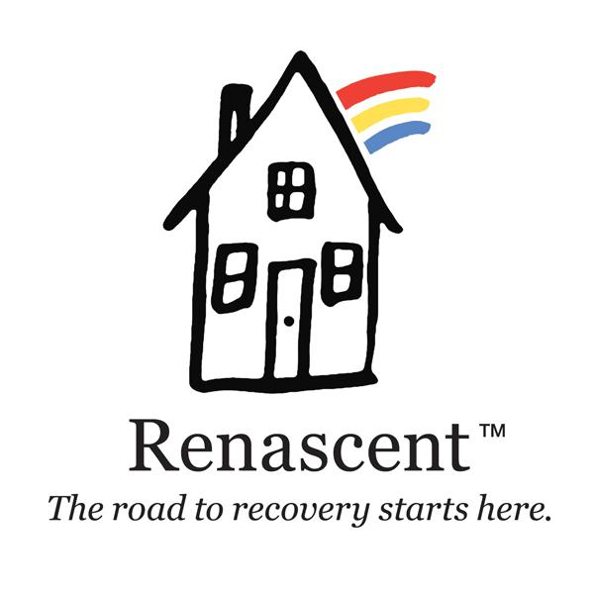

Internship/Placement Request
Contact Information
Name
Street Address
City, Province, Postal Code
Home Phone
Work Phone
Email Address
Availability
During which hours are you available for placement / co-op?
___ Weekday mornings | ___ Weekend mornings
___ Weekday afternoons | ___ Weekend afternoons
___ Weekday evenings | ___ Weekend evenings
Interests
In which areas you are interested completing your internship/placement?
Sullivan House ___ Addiction Counselling ___ Outreach
Munro House ___ Peer Support ___ Family Program
Punanai House ___ Continuing Care
Wright Center ___ Children’s Program . ___ Client Care Access & Engagement
We also offer co-op placement opportunities in:
- Foundation
- Communications
- Human Resources
- Finance

Special Skills or Qualifications
Summarize special skills and qualifications you have acquired from employment, or through other activities, including hobbies or sports.
Lived Experience with Addiction or 12 Step Recovery

___ Self | ___ Family/ Loved One | ___ None

School Information
Name
Street Address
City, Province, Postal Code
Placement/co-op supervisor's name and contact information
Agreement and Signature
By submitting this request, I affirm that the facts set forth in it are true and complete. I understand that if I am accepted as a student, any false statements, omissions, or other misrepresentations made by me on this student may result in my immediate dismissal.
Name (printed)
Signature
Date

Our Policy

It is the policy of this organization to provide equal opportunities without regard to race, colour, religion, national origin, gender, sexual preference, age, or disability.
Renascent is an equal opportunity employer. Accommodations will be provided in accordance with the Ontario Human Rights Code.
Thank you for completing this request form and for your interest in Renascent.

